

Productive Resources Congratulates SureShot USA on Launch of the Locking M4 Stock Adapter

Productive Resources is proud to congratulate SureShot USA on the successful launch of their new Locking M4 Stock Adapter, an innovative component designed to expand compatibility and customization for AKM (stamped) platforms.

The newly released adapter enables users to attach their preferred M4 style stock, brace, or SureShot USA’s own SS-12 stock to side folding AKM rifles. This design delivers increased flexibility, modularity, and end user personalization while maintaining the durability and performance demanded by modern firearm platforms.

Productive Resources was honored to support SureShot USA throughout the development of this product and greatly enjoyed collaborating with their talented and passionate team. SureShot USA’s commitment to precision engineering, performance, and thoughtful product innovation closely aligns with the values Productive Resources brings to every engineering partnership.

We congratulate the entire SureShot USA team on a successful product launch and look forward to seeing what they build next.
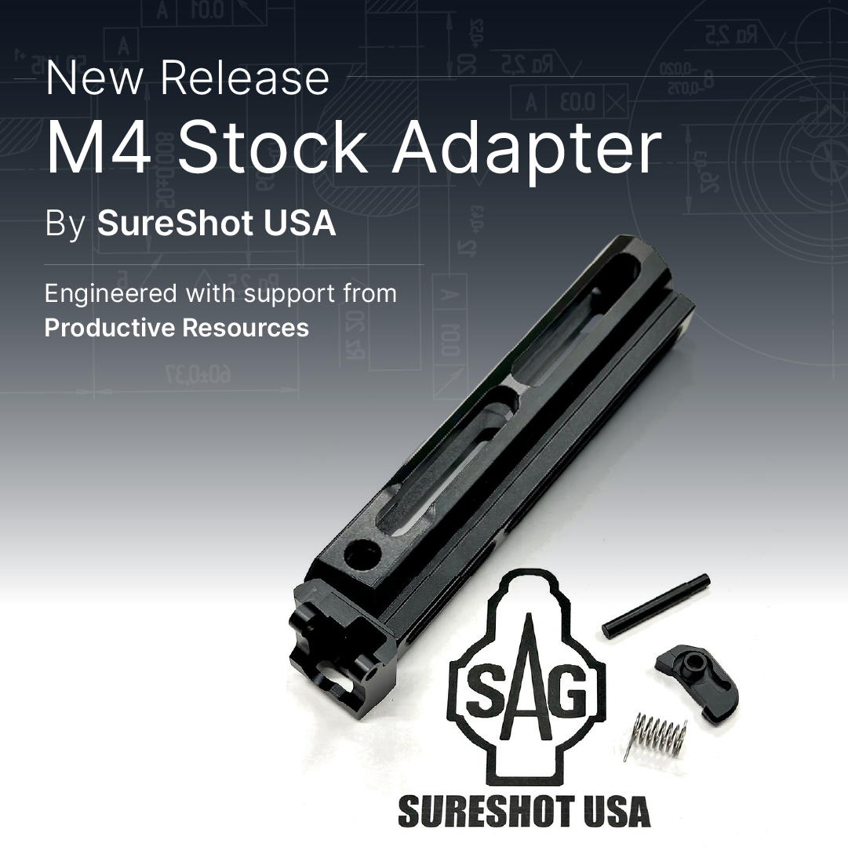

About Productive Resources
Productive Resources provides flexible engineering services across mechanical, electrical, software, and program management disciplines, helping manufacturers and OEMs bring innovative products to market efficiently and reliably.

Media Contact:
Productive Resources
www.productiveresources.com

